Results Summary for Power BI Project 3 for Udacity Nanodegree

Question 1:
- What is the correlation between sales and income?

Dear reviewer as you can see, the scatterplot below displays the linear regression relationship between Sales and Income, accompanied by the correlation value of 0.78 calculated for these variables.

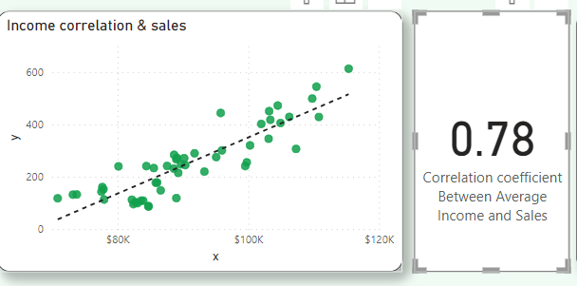

Question 2:
- What is the correlation (R2 value) between customer ratings and product return rate?

The correlation of -0.83 between Customer Ratings and product return rate indicates that products with higher ratings tend to have a lower return rate. The lineplot below illustrates the linear regression between these variables, along with the associated card displaying the calculated correlation value.

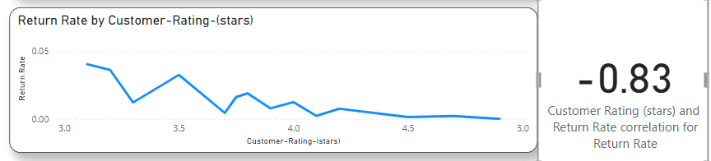

Question 3:
- What is the top recommended item?

The donut chart presented below showcases the recommended item percentages, where the leading product is 'Sweater,' comprising 66% of the total score.
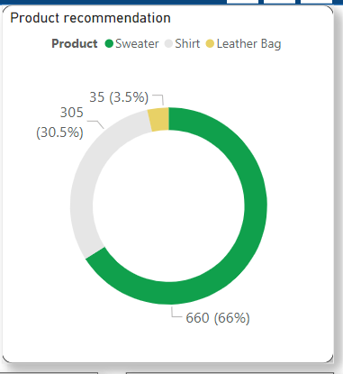

Question 4:
- What are the top products by price in stock?

The below bar charts provide a visual representation of our top 10 in-stock products, organized by their respective prices.

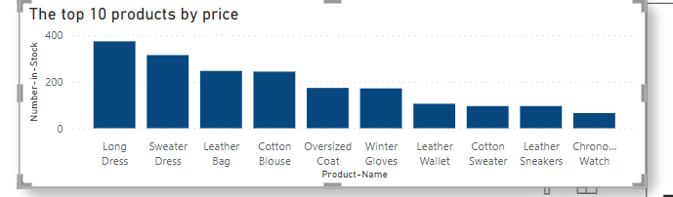

Question 5:

- What are the best and worst performing products?

These two cards depict the products that excel and those that underperform in terms of both return rate and customer ratings.
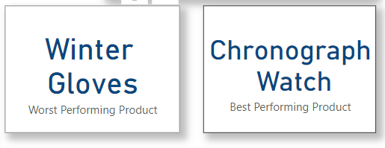

Thank you!

